n���˙���z� w˛˙�ъ� «:�¸n�:›��:� u���˙ъ��–u�¸¬�'c��˙ u�¬'���z� «:�¸n�:›��:� u���˙n��˙
�n���w˙u� w�˙���� ������c�� c��:���w˙– 737�o2 �n���w˙u�
INDIAN CoUNCIL oF AGRICULTURAL RESEARCH-
Research Comp1ex for NEH Region Sikkim Center, Tadong, Gangtok-7371o2, Sikkim, Emai1: jdsikkim.icar@gmai1.com
F.No. ICAANEH/SKC/ST/30/TSP/2025/1421 Date: 11.12.2025

�*����o

MESCOM

MAN�ALORE ELECTRICITY SUPPLY COMPANY LIMITED
(A Government of Karnataka undertaking)
Corporate Office, “MESCOM BHAVANA”, Bejai, Mangalore - 575 004
Ph: 0824-2885795 CIN: U40109 KA 2002 SGC 030425

GeM BIDDING NoTICE
GeM bidding is invited for procurement of (1) 32 mm HDPE Pipe 3600 m & (2) 32 mm HDPE Pipe 12000 m, ICAR RC NEHR, Sikkim Centre, Tadong, Gangtok-7371o2, vide GeM Bid No: (1) GEM/2025/B/6984256 Date: 10.12.2025 & (2) GEM/2025/B/6984413 Date: 10.12.2025 for ICAR Research Comp1ex for North Eastern Region, Sikkim Centre, Tadong-7371o2, Gangtok from reputed firms/agency. Interested bidders may visit GeM porta1 Govt. of India. The detai1s are given be1ow: -
No. E-237061/268681 Date: 02.12.2025
TENDER NOTIFICATION (THROU�H KPP PORTAL ONLY)
MESCOM invites tender for Manufacture & Supply of following material:

Name of the Material

Bid No: (1) GEM/2025/B/6984256 Date: 10.12.2025
(2) GEM/2025/B/6984413 Date: 10.12.2025
Bid End Date/Time (1) 20-12-2025 15:00:00
(2) 20-12-2025 15:00:00
Bid Opening Date/Time (1) 20-12-2025 15:30:00
(2) 20-12-2025 15:30:00
Bid offer Validity (From End Date) 30 (Days)

Sd/-

Tender No
MESCOM/2025-26/ IND0123
MESCOM/2025-26/ IND0150

proposed for Procurement
Uniform Clothes as per Technical Specifications
No.8 Strain Insulator

Quantity

19,813.78 Mtrs

1,20,000 No's

(Ashok Kumar) Head of Regional Centre
The interested eligible bidders may log on to
www.kppp.karnataka.gov.in on or after 12.12.2025

DIPR/DK/KSMCA/1238/ 25-26 dt: 11.12.2025
Sd/-, Superintending Engineer (Ele) (Procurement)

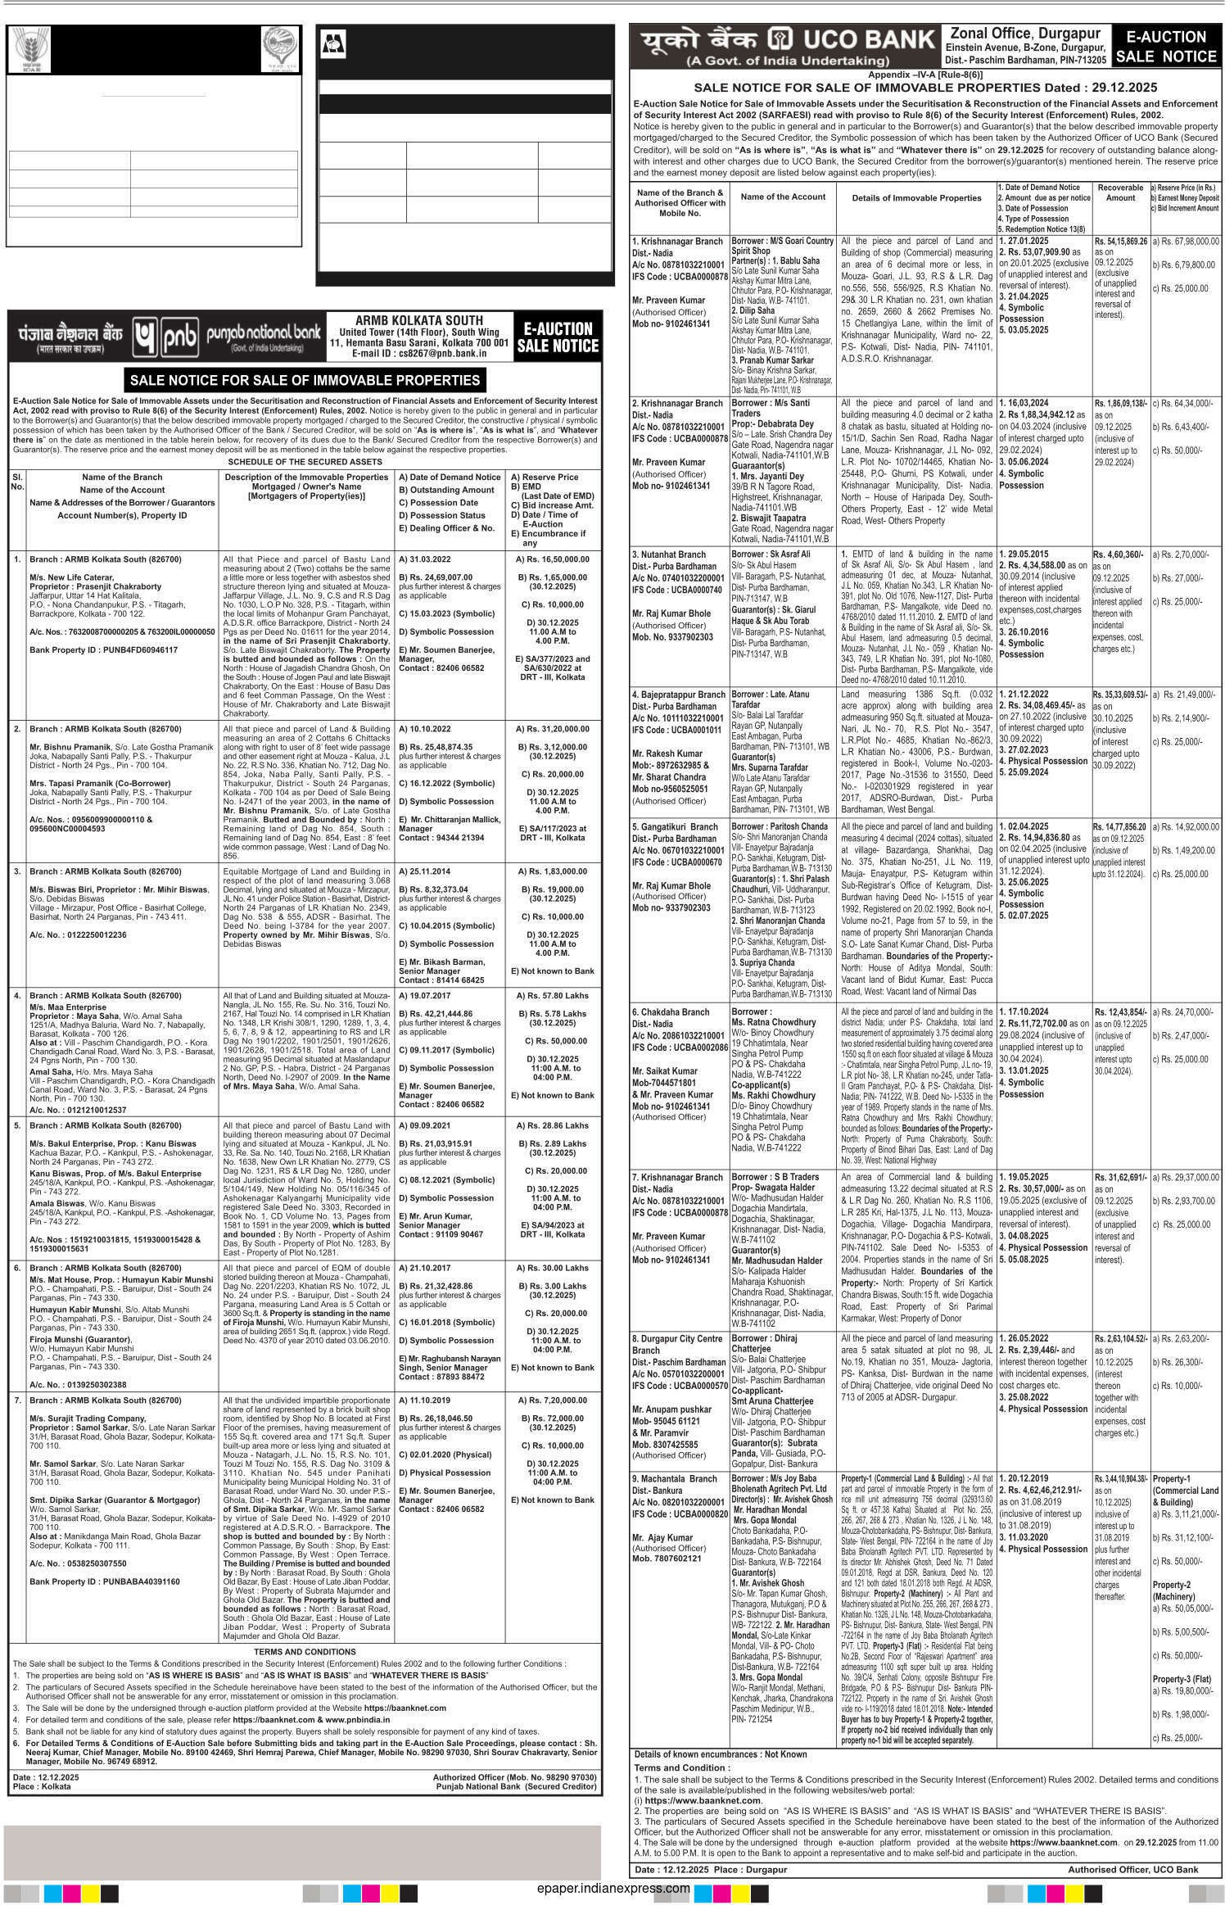
For Power Related Complaints & Assistance Call Toll Free Number 1912

Ko1kata

