MONDAY, DEcEMBER 8, 2025
WWW.FlNANclALEXPRESS.cOM

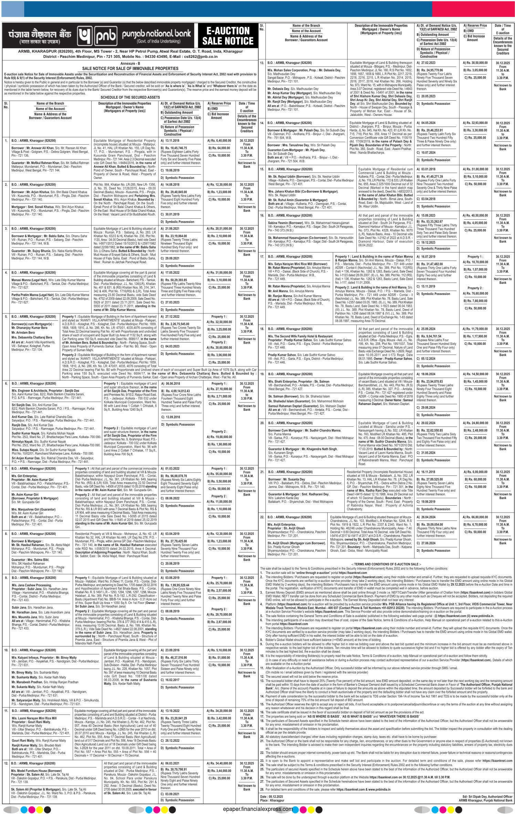
12 FlNANclAL EXPRESS

Ko1kata

