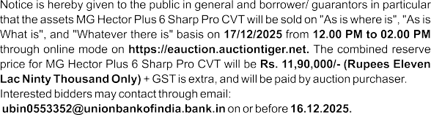




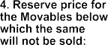
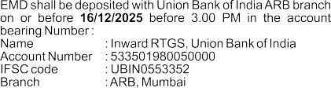
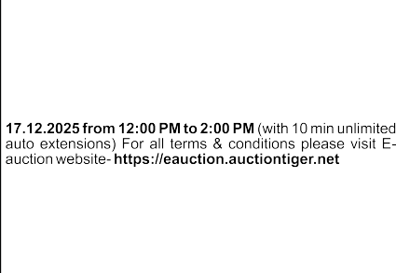
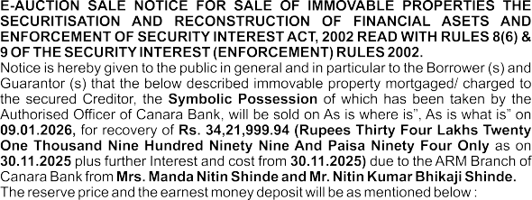

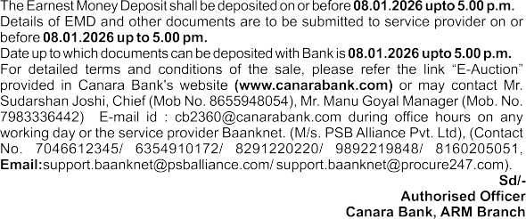


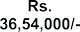
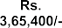
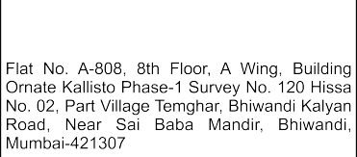
www.freepressjournal.in
Mumbai, Wednesday, December 3, 2025 The free pressJournal 23



LOAN COLLECTION AND RECOVERY DEPARTMENT
Federal Towers, Head Office, Aluva, Kerala, India-683101
E-mail : lcrd@federalbank.co.in, Phone : 0484-2634051, 2634164
URGENT
Intimation Regarding Unserved Official Communication
- Mr. Aslam Karim Mujawar
Address 1 : Room No. 16, 2nd Floor, Janai Joma Niwas,
H. No. 239, Sector 16, Koparkhairane,
Navi Mumbai, Thane, Maharashtra-400 709. Address 2 : Flat No.701, 7th Floor, C-Wing, Rajhans Apartment, Sai Kripa C Wing CHSL,
J P Road, Nirmal Nagar, Khar (East), Mumbai-400051.
- Mrs. Sakina Bano
Address 1 : Flat No. 701, 7th Floor, C-Wing, Rajhans Apartment, Sai Kripa C Wing CHSL,
J P Road, Nirmal Nagar, Khar (East), Mumbai-400051.
Address 2 : Ghatkopar Mankhurd Link Road, Dr. Zakir Husain Nagar, Govandi West, Shivaji Nagar, Mumbai, Maharashtra-400043.
This communication concerns a critical formal notice dated 06/11/2025, which was sent to your above-mentioned addresses regarding your transactions with the Bank. Unfortunately, the notice was returned unserved. Additionally, this notice references a prior communication dated 11/09/2025, which was published in The Free Press Journal and Nava Shakthi on 27/09/2025. You are advised to contact our office within 15 days from the publication date of this notice to obtain details of the proceedings. Failure to do so will compel the Bank to proceed further in the matter in your absence, in accordance with applicable laws and guidelines.
For The Federal Bank Limited,
Date : 02/12/2025 Santhosh Kumar V C Place : Aluva, Kerala Vice President

DRAINAGE DEPARTMENT TENDER NOTICE
E- tenders are invited for (1) Providing, Laying sewer lines and construction of machine holes for missing link in sewerage system at Ghodbunder Service road in Vartak nagar ward committee in Thane Municipal Corporation Limit.(2) Providing, Laying sewer lines for sewer connection of public toilets in ward no 15(B)in Lokmanya- Sawarkar nagar ward committee in Thane Municipal Corporation Limit.Participation in this tenders will be prohibited for those bidders against whom penal action of de-registration has been taken /initiated by any Government
/ Semi Goverment /Public Sector Undertaking / Urban Local Body /Municipal Corporation etc. Tenders has to be purchased and submitted by E- tendering procedure only. Tenders will be available on websites https:/mahatenders. gov.in from 03/12/2025 to 10/12/2025 up to 16.00 hrs. The tender has to be submitted on above websites on or before date 10/12/2025 up to 16.00 hrs by E- tendering procedure and Technical bid for these tender will be opened on 11/12/2025 at 17.00 hrs if possible, in the presence of tenderers or their representative.
TMC/PRO/Drainage/954/2025-26 Sd/- Dt.02.12.2025 City Engineer, pls visit our official web-site Drainage Department
www.thanecity.gov.in Thane Municipal Corporation

 | (A) | (B) | (C) | (D) | (E) | (F) | (G)
Sr No | Name/s of Borrower(s)/ Mortgager(s)/ Guarantor(s)/ Legal Heirs and Legal Representatives (whether known or unknown) Executor(s), Administrator(s), Successor(s) and Assign(s) of the respective Borrower(s) / Mortgagor(s) / Guarantor(s) (since deceased), as the case may be. | Outstanding dues to be recovered (Secured Debt) (Rs.)* | Description of the Immovable Property / Secured Asset (1 Sq. mtr. is equivalent to 10.76 Sq. ft) | Type of Possession | Reserve Price (Rs.) | Earnest money deposit  (Rs.) | Date of Auction and time
VIRAR [WEST]
1 | MR KANTHE JITENDRA BABAN & MRS KANTHE SHAILA JITENDRA | Rs. 37,30,290/-  As on 31-OCT-2023* | FLAT NO 1701, 17TH FLOOR, BUILDING NO T-7, SUMMIT TOWER, JOYVILLE VIRAR PHASE I, SURVEY NO 390/B (PART) OF VILLAGE BOLINJ, VIRAR [WEST], TALUKA VASAI, DISTRICT PALGHAR – 401303  ADMEASURING 716.02 SQ. FT. CARPET AREA WHICH IS EQUIVALENT TO 66.52 SQ. MTRS. CARPET AREA OR THEREABOUTS. | PHYSICAL POSSESSION | Rs. 53,10,000/- | Rs. 5,31,000/- | 03-JAN-2026  10.00 am  to  10.30 am
- Inspection Date & Time: 11-DEC-2025 between 11.00 am to 4.00 pm
- Minimum bid increment amount: Rs. 25,000/-
- EMD Amount Submission on or before: 01-JAN-2026
PALGHAR [WEST]
2 | MR KANOJIYA RAJENDRA PRASAD & MR KANVAJIYA JAGDISHL PRASAD | Rs. 17,37,354/-  As on 30-JUN-2021* | FLAT NO 403, 4TH FLOOR, BUILDING NO 10, ADINATH APARTMENT, SURVEY NO 404/2, 407/1, 2, VILLAGE MAHIM, VAGULSAR, PALGHAR [WEST], DISTRICT PALGHAR – 401404  ADMEASURING 570 SQ. FT. i.e. 52,97 SQ. MTRS. BUILT-UP (WHICH IS INCLUSIVE OF BALCONIES AREA AND ALL UTILITY AREAS ALONG WITH RCC STRUCTURAL ELEMENT). | PHYSICAL POSSESSION | Rs. 14,50,000/- | Rs. 1,45,000/- | 03-JAN-2026  10.30 am  to  11.00 am
- Inspection Date & Time: 12-DEC-2025 between 11.00 am to 4.00 pm
- Minimum bid increment amount: Rs. 25,000/-
- EMD Amount Submission on or before: 01-JAN-2026
PALGHAR [WEST]
3 | MR BHANDARI JITENDRA &  MR BHANDARI NARPATCHAND MADANMOHANCHAND | Rs. 6,30,324/-  As on 31-OCT-2022* | SHOP NO 13, WING C, BUILDING NO 1, SHIVAM AURA, TYPE E1, SURVEY NO 404/2, 407/1, 2, VILLAGE MAHIM, PALGHAR [WEST] – 401404  ADMEASURING 96.62 SQ. FT. CARPET AREA WHICH IS EQUIVALENT TO 8.97 SQ. MTRS. CARPET AREA OR THEREABOUTS. | PHYSICAL POSSESSION | Rs. 8,25,000/- | Rs. 82,500/- | 03-JAN-2026  11.00 am  to  11.30 am
- Inspection Date & Time: 15-DEC-2025 between 11.00 am to 4.00 pm
- Minimum bid increment amount: Rs. 25,000/-
- EMD Amount Submission on or before: 01-JAN-2026
PALGHAR [WEST]
4 | MRS PARMAR VEENA MITESH | Rs. 17,31,329/-  As on 31-DEC-2023* | FLAT NO 304, 3rd FLOOR, A WING, TYPE A, “FIA TULIP”, BUILDING, SURVEY NO 831, HISSA NO 2P, PLOT NO 15 AND 16, VILLAGE MAHIM, PALGHAR [WEST], DISTRICT PALGHAR – 401404  ADMEASURING 235.32 SQ. FT. RERA CARPET AREA + 45.83 SQ. FT. OPEN TERRACE AREA WHICH IS EQUIVALENT TO 26.13 SQ. MTRS. CARPET AREA OR THEREABOUTS. | PHYSICAL POSSESSION | Rs. 13,87,000/- | Rs. 1,38,700/- | 03-JAN-2026  11.30 am  to  12.00 noon
- Inspection Date & Time: 16-DEC-2025 between 11.00 am to 4.00 pm
- Minimum bid increment amount: Rs. 25,000/-
- EMD Amount Submission on or before: 01-JAN-2026
PALGHAR [WEST]
5 | MR NAIK ANAND SADANAND & MRS NAIK ANUSAYA SADANAND | Rs. 17,63,187/-  As on 31-JAN-2023* | FLAT NO 25, 4th FLOOR, BUILDING NO 9, E TYPE, HAWARE'S NAKSHATRA, SURVEY NO 66, HISSA NO 1(P), VILLAGE TEMBHODE, PALGHAR [WEST] – 401404  ADMEASURING 347 SQ. FT. CARPET AREA WHICH IS EQUIVALENT TO 32.31 SQ. MTRS. CARPET AREA OR THEREABOUTS. | PHYSICAL POSSESSION | Rs. 12,50,000/- | Rs. 1,25,000/- | 03-JAN-2026  12.00 noon to  12.30 pm
- Inspection Date & Time: 17-DEC-2025 between 11.00 am to 4.00 pm
- Minimum bid increment amount: Rs. 25,000/-
- EMD Amount Submission on or before: 01-JAN-2026
BOISAR [EAST]
6 | MR PHADKE MADHUSUDAN VAMAN | Rs. 9,35,360/-  As on 31-AUG-2022* | FLAT NO 103, 1st FLOOR, B WING, BUILDING NO 4, DREAM CITY, SECTOR 9, SHIRGAON ROAD, S NO 74/1 (NEW 46/1), 74/2 (NEW 46/2), 75 (NEW 47), 76(NEW 45) & 85 (NEW 44), BOISAR [EAST], TALUKA PALGHAR – 401501  ADMEASURING 500 SQ. FT. CARPET AREA WHICH IS EQUIVALENT TO 46.46 SQ. MTRS. CARPET AREA OR THEREABOUTS. | PHYSICAL POSSESSION | Rs. 8,75,000/- | Rs. 87,500/- | 03-JAN-2026  12.30 pm  to  01.00 pm
- Inspection Date & Time: 18-DEC-2025 between 11.00 am to 4.00 pm
- Minimum bid increment amount: Rs. 25,000/-
- EMD Amount Submission on or before: 01-JAN-2026
BOISAR [EAST]
7 | MISS SAWANT SHWETA ASHOK | Rs. 17,49,593/-  As on 30-JUN-2021* | FLAT NO K1/33, 3RD FLOOR, HAPPINEST PH II, CLUSTER K-33, BLDG K1, PLOT 1, SURVEY NO 50, NEAR EKLAVYA HIGH SCHOOL, KAMBALGAON, BETEGAON OFF ROAD, BOISAR [EAST], DISTRICT PALGHAR – 401501  ADMEASURING 376.28 SQ.FT. CARPET AREA WHICH IS EQUIVALENT TO 34.97 SQ. MTRS CARPET AREA OR THEREABOUTS. | PHYSICAL POSSESSION | Rs. 8,10,000/- | Rs. 81,000/- | 03-JAN-2026  01.00 pm  to  01.30 pm
- Inspection Date & Time: 19-DEC-2025 between 11.00 am to 4.00 pm
- Minimum bid increment amount: Rs. 25,000/-
- EMD Amount Submission on or before: 01-JAN-2026
BHIVPURI [EAST], KARJAT
8 | MR SONAWANE LALITKUMAR BHAGWAN | Rs. 32,65,701/-  As on 30-JUN-2024* | FLAT NO 403, 4th FLOOR, D WING, SAURABH RESIDENCY, SURVEY NO 84/1A, VILLAGE UKRUL, BHIVPURI [EAST], TALUKA KARJAT, DISTRICT RAIGAD – 410201  ADMEASURING 409 SQ. FT. CARPET AREA + EXCLUDING BALCONY 90 SQ. FT. (APPROXIMATE CARPET AREA) WHICH IS EQUIVALENT TO 46.37 SQ. MTRS. CARPET AREA OR THEREABOUTS. | PHYSICAL POSSESSION | Rs. 28,00,000/- | Rs. 2,80,000/- | 03-JAN-2026  01.30 pm  to  02.00 pm
- Inspection Date & Time: 20-DEC-2025 between 11.00 am to 4.00 pm
- Minimum bid increment amount: Rs. 25,000/-
- EMD Amount Submission on or before: 01-JAN-2026
VILLAGE DAHIVALI, KARJAT
9 | MR GAIKAR LAVESH TUKARAM & MRS GAIKAR POOJA LAVESH | Rs. 5,83,051/-  As on 30-SEP-2024* | SHOP NO 02, GROUND FLOOR, VARAD CO-OPERATIVE HOUSING SOCIETY, CTS NO 99, 100, 101, 102 OF VILLAGE DAHIVALI, TALUKA KARJAT, DISTRICT RAIGAD 410201  ADMEASURING 107 SQ. FT. CARPET AREA WHICH IS EQUIVALENT TO 9.96 SQ. MTRS. CARPET AREA OR THEREABOUTS. | PHYSICAL POSSESSION | Rs. 7,35,000/- | Rs. 73,500/- | 03-JAN-2026  02.00 pm  to  02.30 pm
- Inspection Date & Time: 22-DEC-2025 between 11.00 am to 4.00 pm
- Minimum bid increment amount: Rs. 25,000/-
- EMD Amount Submission on or before: 01-JAN-2026

